**Benefits of Naturopathy Diet- Choose or loose**

**Add life to your routine**

Leave your old life behind and focus on what’s coming. There are many escape ways. You just make an excuse and run away. But is that really a solution? Finding a solution itself provides an opportunity to grow. Serving an opportunity for you, Naturopathy diet benefits in rapid growth of your body!

Growth? Do I still need to grow?

This growth isn’t related to height, but to inner strength and immunity. If a body is strong and highly immune, it is saved from hundred risks that attack weak people. And benefits of naturopathy diet are going to help you grow.

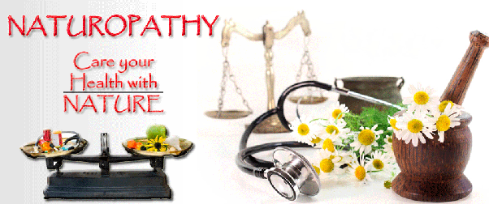

**What is Naturopathy diet?**

Naturopathy diet is a natural way to rejuvenate the inner organs and provide nourishment to the whole body. When the internal system becomes healthy, the outer body radiates with refreshment.

Naturopathy diet is an old remedial technique. Benefits of naturopathy diet include inculcating the lost nutrients back into the body. A tree grows to its full strength only when taken care of properly. Similarly, naturopathy diet (if followed time to time) takes care of body cells to restore health and benefits of naturopathy diet have the power to do so.

Not limited to providing visible benefits, benefits of naturopathy diet include eliminating root causes of many diseases and it heals one from head to toe.

**What is the Naturopathy diet good for?**

For countless reasons, naturopathy diet benefits us. Some major that can be listed are:

* Allergies

How do you think a food allergy arises? It’s either because of specific food allergy or deficiency of certain minerals or vitamins. Naturopathy diet benefits in reducing allergies and cleans the outer layer of skin to prevent further allergy or reaction.

* Headaches

During headaches, we find nothing but bed to sleep. Our eyes start aching and we become restless. To eradicate the cause, benefits of naturopathy diet are discussed here.

* Digestive problems

Main friend or enemy of our life is our stomach! It depends on how we treat it. Digestion process becomes easier with a happy stomach and intestines. Benefits of naturopathy diet come from eating healthy food.

* Obesity

Again, if natural nutrients outweigh junk in our meal, we’ll feel more energetic and no junk food deposits as fats.

* Hormonal imbalance

Here, what is the Naturopathy diet good for? Benefits of naturopathy diet are similar to providing a spa treatment to body tissues. Hence, increases their functionality. Therefore, hormone secretion is balanced.

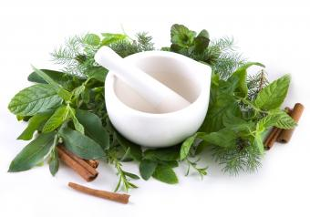

* Fertility issues

Most fertility issues are a result of wrong or unplanned diet taken before getting pregnant. A balanced diet with essential nutrients is a way to good healthy life. They are provided by benefits of naturopathy diet.

* Good eating habits

Naturopathy diet benefits not only in reaching a goal weight but also in developing good eating habits in us.

**Choose- Naturopathy diet or health issues**

It is said that habits aren’t permanent, they can be changed! Change them for a good! Adopt naturopathy diet and benefits of naturopathy diet come handy. What is the naturopathy diet good for if we don’t allow ourselves to take advantages of naturopathy diet?

Who all can take benefits of naturopathy diet?

Pregnant women, breastfeeding women, very high BP patients, people with digestive issues, teenagers etc are not advised to take naturopathy diet. However, disease-prone people can consult their dietician about the pros and cons of naturopathy diet good for them.

Conclusion

Benefits of naturopathy diet looks minor but are proved exceptionally helpful to many people. And obviously, don’t limit yourself calling it a ‘diet’. One of the benefits of naturopathy diet is it enables you to explore a variety of food rather than relying on the same junk food.